

Milestone II

Instruction Manual



December 10, 2021

MileStone 2 folder has three folders in it.

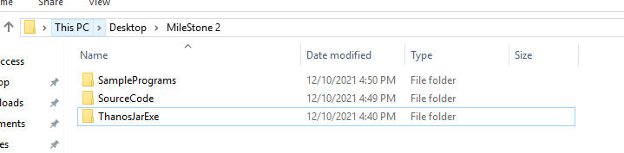

To run the sample files, Open ThanosJarExe folder.

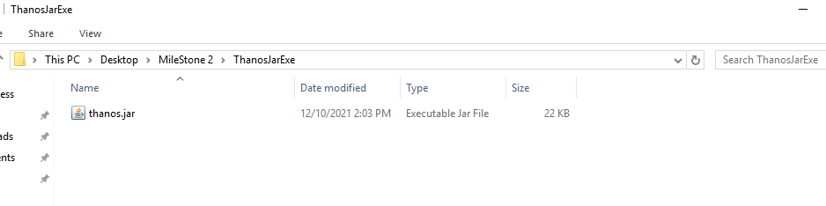

On windows machine, type cmd on address bar and click enter to open the command prompt with current folder path.

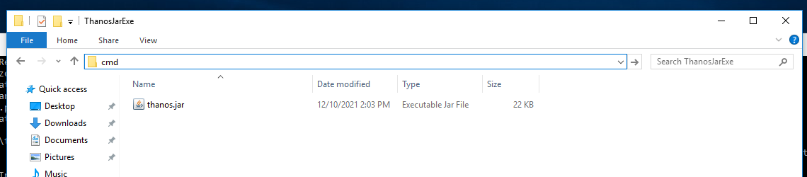

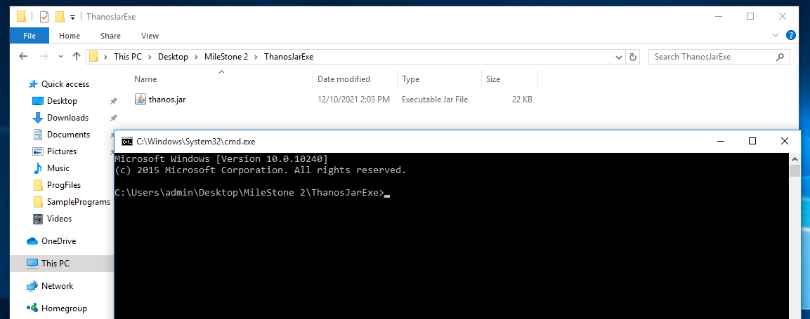

Run below commands after adjusting the path as per the current location of MileStone 2 file. In our case, MileStone 2 is located at C:\Users\admin\Desktop

java -jar thanos.jar "C:\Users\admin\Desktop\MileStone 2\SamplePrograms\inheritance.thanos"

java -jar thanos.jar "C:\Users\admin\Desktop\MileStone 2\SamplePrograms\BubbleSort.thanos"

java -jar thanos.jar "C:\Users\admin\Desktop\MileStone 2\SamplePrograms\ThanosPrint.thanos"

OutPut

Thanos Print Program

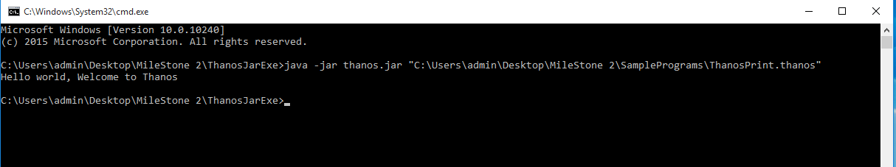

BubbleSort Program

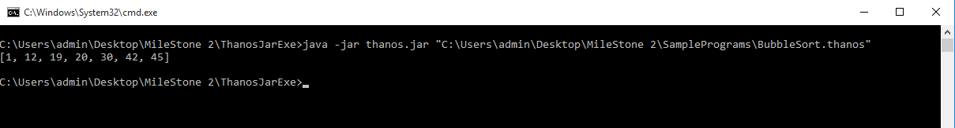

Inheritance Example

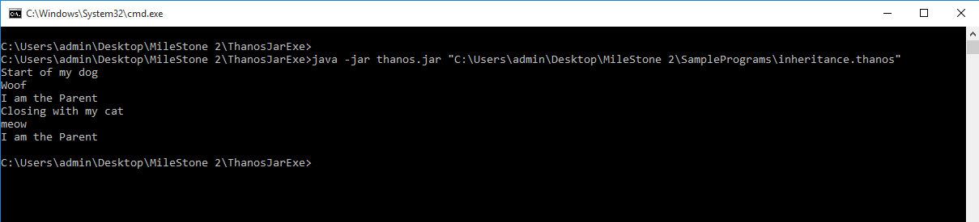

Sample Programs can be found in SamplePrograms folder and Source Code can be found in the sourceCode folder.

If we want to run the files from source code, we can user Application Class file and need to make the below mentioned changes.

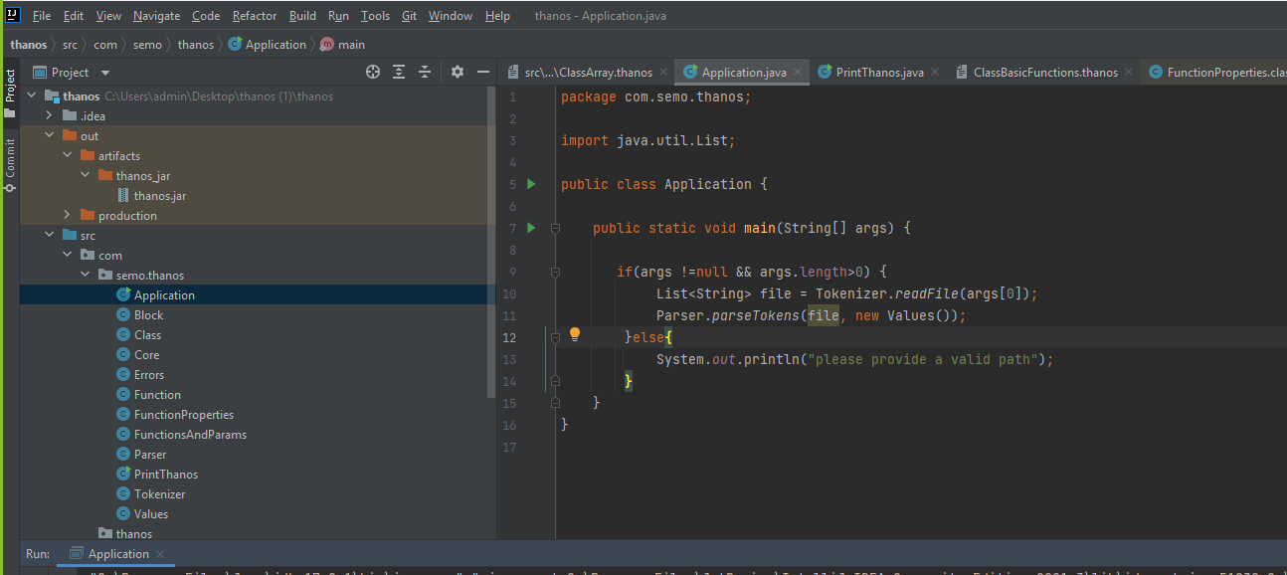

Delete Line 9 –

if(args !=null && args.length>0) {

Delete Lines from 12-14

}else{  
 System.*out*.println("please provide a valid path");  
}

In Line 10, replace args[0] with file path as shown below

List<String> file = Tokenizer.*readFile*("C:\\Users\\admin\\Desktop\\MileStone 2\\SamplePrograms\\inheritance.thanos");

And run the program

